Project 12-1: Monthly Balance Calculator with Validation

User interface
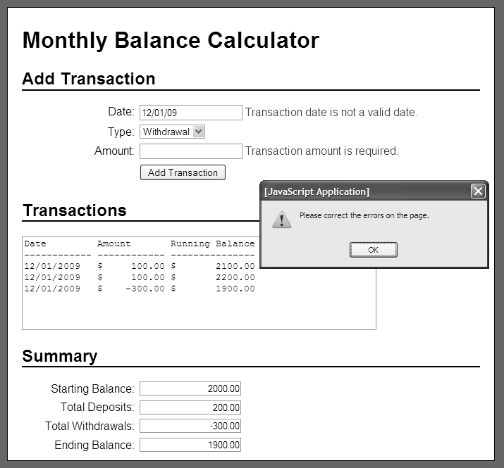

Operation
- This project works like project 10-1, but it validates the user entries.
- This application allows the user to enter deposits and withdrawals for a bank account, and it calculates and displays the deposits and withdrawals with a running balance as well as the starting balance, total deposits, total withdrawals, and ending balance.

Specifications
- Store the transactions in an array of arrays.
- Use functions to organize the code for this application.
- Assume that the account will have a starting balance of 2,000.
- Validate all user entries:
- For the transaction date, make sure that the user enters a valid date in the mm/dd/yyyy format where the year is between 1,000 and 3,000.
For the transaction amount, make sure that the user enters a valid number between 0 and 100,000.

